SL160 Startup and Calibration

Note: All screens/dialogs not to scale and layout is for illustrative purposes only and may not be representative of final implementation.

# CONNECT

1. Auto-Connect to last used COMn port
2. Connect to new port if last port no longer valid.

# CHECK CALIBRATION

If no calibration stored in the stage eeprom:

1. Query what type of system we are controlling. Probably only needed during factory calibration. Selection stored as part of calibration data. There are three main types:
   1. Fixed height stage – as with Open Stand configuration
   2. Variable height stage – focus controlled by customer microscope and software (e.g. Leica).
   3. Variable height stage – customer microscope but focus controlled from PS3. We should build this option into the design now.

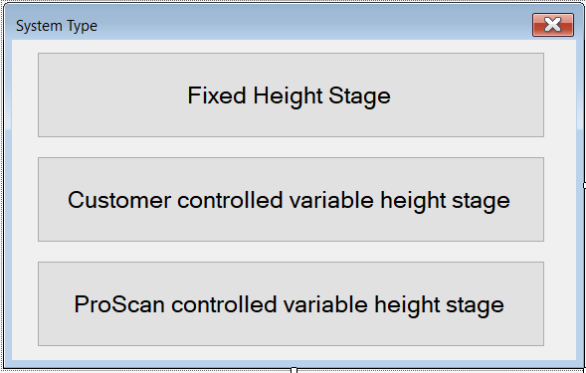

# INITIALISE

1. Initialise stage shuttle to zero position (this enables us to remove the shuttle from a possibly compromised position in hotel). If stage sensor reports tray on stage, prompt user to perform visible check for tray on stage. Report any discrepancy between reported state and sensor status to user as possible sensor fault. It is not an error to end up having a real tray on the stage at this point; it can be because the system was stopped when inserting or extracting a tray from the hotel. See later on how to recover from finding a tray on the stage after initialisation.

Both graphical and textural information are displayed during the initialisation and calibration phases along with the step identification.

Where possible the user will be able to backtrack through the process.

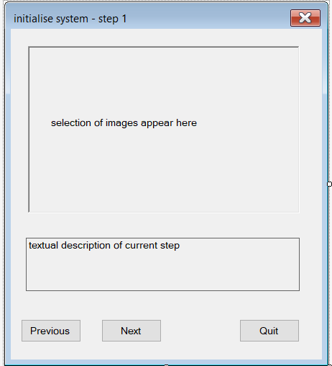

1. Initialise Stage – stage moves to back right and establishes zero reference point. All movement left and forward of this point is considered +ve position.
2. Initialise Z (if needed). Based on start-up system type query either PS3 homes to lower limit of its drive or user software controls microscope focus mechanism to its reference point.
3. Initialise hotel loading and lifting axes.

Q: do we need a step by step process here, or can we just run though it showing the user what is happening?

The loader axes are all homed and controlled within the DLL. The Stage XYZ are controlled via the demo program. The reason? I can foresee a customer not wanting to follow our stage co-ordinate system and resolution. Having that knowledge in the GUI (rather than the dll) means the customer can re-define it in his software (or our demo as we provide source as example) – he will of course have to recalibrate.

**For variable height stages, customer is responsible for defining both the load height of the stage and the focal height, escaping the stage clear of the objectives prior to loading/unloading a tray and re-focusing on a loaded sample**.

**The load height will have to be within a certain specified range else they may ne be able to access all apartments in the hotel**.

Steps 2 to 4 are performed only if this is a cold start (ie first initialise after power cycle of SL160)

# NORMAL OPERATION

If all calibration is complete, then we go straight to normal operating screen. This document does not detail normal operation.

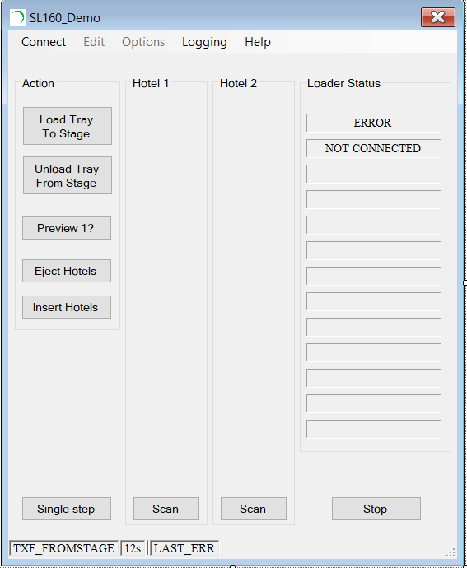

A quick start checklist option will provide a step-by-step run through of the calibration:

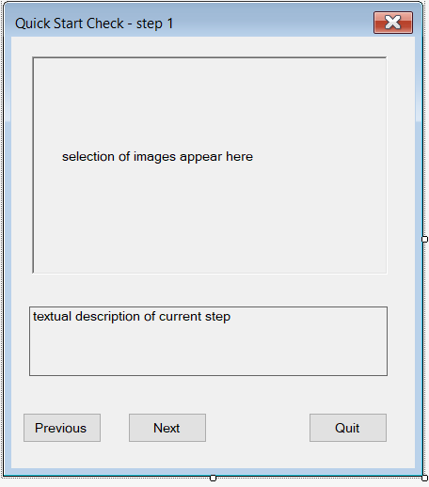

1. Prompt user to open door and eject hotel loading mechanism (images required).
2. Prompt user to fit both hotels with top and bottom trays fitted (images required).
3. When both are fitted, prompt user to insert hotels.
4. Scan both hotels. Prompt user to Eye-ball check that both hotels have been lifted cleanly
5. Check that only the requisite 4 trays are detected, showing a warning if not and allow user to go back to 1 and reload correct amount of trays, or to abort due to sensor miss-read/failure.
6. If the tray on stage sensor is active, query with user there really is one. Raise sensor error if not. If there really is a tray on the stage, attempt to remove it to hotel 2 slot 19.
7. Cycle through all original 4 trays and load/unload each to stage. Checking for smooth operation, no problems lifting or switching between hotels, inserting and extracting trays from stage etc.

Each step will show one or more images pertaining to that phase of the process.

The quick start check option will also available at all times from the menu or user can manually perform the functions from the GUI controls.

If calibration is not acceptable then select appropriate recalibrate option from menu. System will automatically restart from here.

# RECOVER FROM INITIALISATION WITH TRAY ON STAGE

If the calibration is already completed then sequence for this recovery is:

1. Eject hotels
2. Load at least one hotel with at least one empty apartment.
3. Insert hotel(s).
4. Scan hotels(s).
5. Unload tray from stage to empty apartment.
6. Eject hotel(s).
7. User removes tray.

If calibration is incomplete then the tray is kept on the stage and be used/removed later.

# REDO CALIBRATION

You can do all or part of the calibration from here.

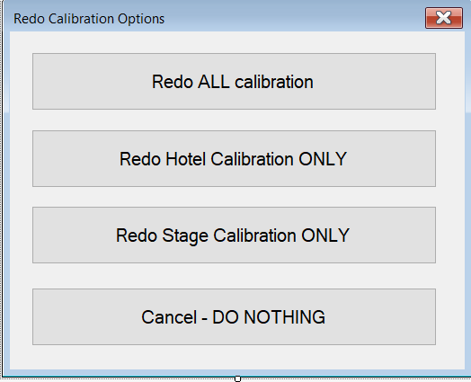

Stage eeprom data and INI files will be modified according to request and the cold start flag reset, followed by an automatic disconnect/reconnect which results in continuing from here.

# PRODUCTION

After production test has completed the calibration must be set back to the level needed for that particular customer order. If stage height is fixed (i.e. an open stand variant system) then all calibration should be left in place and system delivered as-is.

If the stage height is variable, either controlled entirely by users microscope, or via PS3 focus motor attached to user microscope, then production engineer must invalidate the stage calibration by clicking the “Redo Stage Calibration ONLY” option, and exit the application, leaving the stage calibration to be completed on the customers site.

There are flags in the SL160 calibration data shows which parts of the calibration still need to be completed. The following screens only shown if the relevant calibration required.

# HOTEL CALIBRATION

1. Prompt user to eject hotels (image of door open and ejected hotel shuttle)

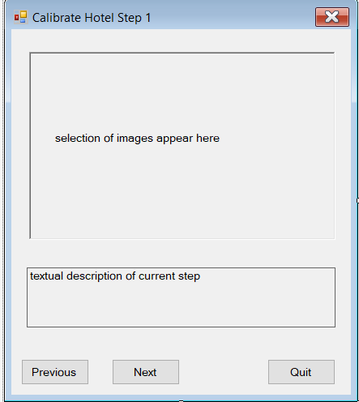

1. Prompt user to load empty hotel to position 1. (Image of hotel 1 in place)
2. Check correct hotel fitted, then load to zero position.
3. Show images of what we are trying to achieve regarding the alignment of the lifting mechanism with respect to the hotel bracket.
4. Request user to jog hotel position until aligned (jog buttons made visible).

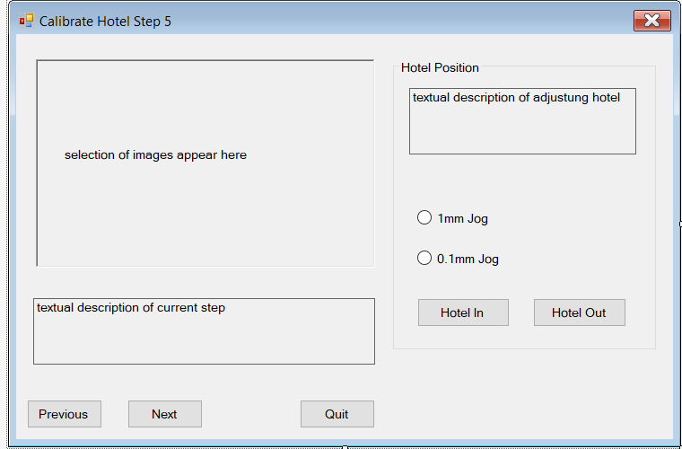

1. Prompt user to test lift and drop of hotel, user ensuring smooth operation. (Images required).Then Next or Previous (back to 4).

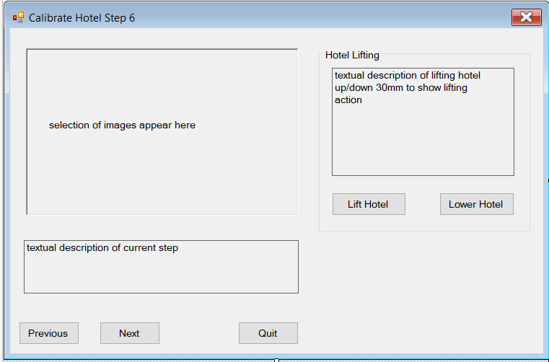

1. Prompt user to auto eject hotel to complete the hotel calibration.

Hotel 2 is a fixed distance from hotel 1 and it is not necessary to calibrate individually or test lift/load as there should be no mechanical tolerance build up between positions.

The dialog sequence continues with stage calibration (if needed) followed by saving calibration.

# STAGE CALIBRATION

1. If variable stage height system, either, drive the PS3 focus to known height (TBD) or users software must control their own microscope focus mechanism (microscope dependent position).

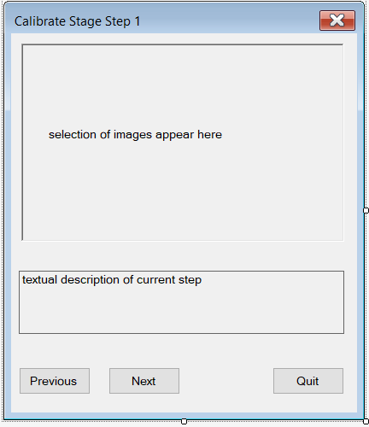

Steps are numbered for easy identification.

1. Prompt user to auto eject hotel shuttle, thus ensuring easier access to the slot to position the tray through. This assumes we cannot find a simpler way of just placing the tray on the stage connected to the shuttle, which would make some of these following steps redundant.
2. Enable X-axis joystick, disable Y-axis (feature not yet available in PS3).
3. Auto jog the stage in X to the left limit and then back off limit by (TBD) mm (Image required).
4. Prompt user to joystick the stage in X until the criteria for opening the stage clamp is satisfied (images required). If mechanical tolerances allow step 4 may be sufficient on its own. It not clear how wide the slot in the LHS cover is. Will we also need to move the stage in Y in order to get the tray onto the stage in the first instance?
5. If by some weird sequence we somehow end up here with a tray on the stage, we can skip the instructions on manually loading a tray to the stage and proceed to step 12.
6. Prompt user to place tray onto stage and check that tray slides freely in and out, adjust stage X position as required to ensure clamp open sufficiently to allow free movement (Images required).
7. Prompt user to manually remove tray from stage.
8. Auto jog stage shuttle out to the required position ready to attach the tray. (image of shuttle extended)
9. Prompt user to insert tray to stage such that it is connected to the shuttle arm. (Images of shuttle extended + tray attached).
10. Auto jog stage shuttle back to zero position at low speed (image of shuttle retracted + tray attached).
11. Raise error if sensor not detecting tray. Either quit and address possible HW sensor failure or get user to reload tray to shuttle correctly from step 4 again.
12. Prompt user to load empty hotel to position 1. (Image of hotel 1 in place). We have to trust user that hotel top apartment is empty as we cannot scan yet!
13. Check correct hotel fitted, then auto insert to previously calibrated hotel position.
14. Auto Lift hotel up such that top apartment is aligned to stage height. We will be close for an open stand system, as we know the relative mechanical positions.
15. Prompt user to auto jog the tray out so just proud of the left side of the stage
16. Images required showing how to align the tray within the hotel. Either (as we do now) to the marker on the tray, or via some (yet undefined) setup jig.
17. Disable X-axis joystick, enable Y-axis
18. Prompt user to position stage Y-axis (using joystick) and extend shuttle to the reference mark.

If we over shoot the mark, retract the shuttle and try again.

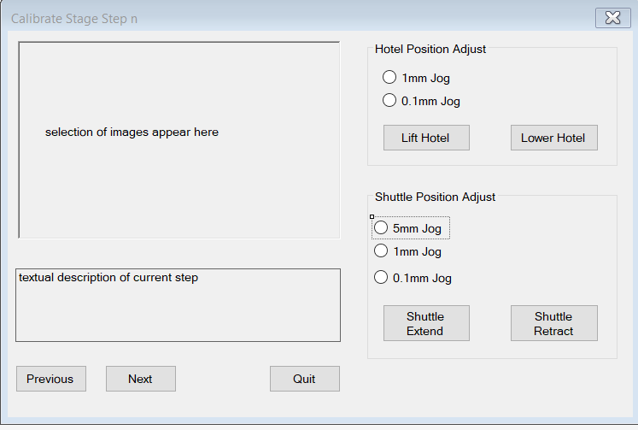

1. Query user to continue and auto insert tray fully to hotel.
2. Prompt user to auto extract tray to stage
3. Prompt user to auto insert back into hotel. Query user to accept position as ok. If not extract and go back to 16) and try again.
4. Prompt user to auto Lift hotel and extract shuttle, leaving tray in hotel.
5. Prompt user to eject hotels.
6. Prompt user to save calibration, quit or restart the calibration routines.

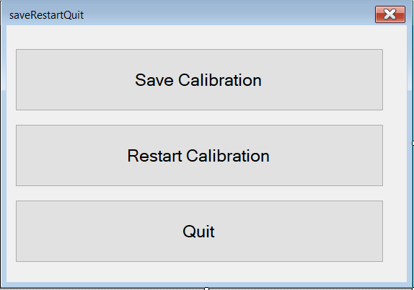

1. If Auto disconnect/reconnect and goto check calibration.

# SAVE CALIBRATION

The motors are turned off and calibration written to the stage eeprom. Note: positional accuracy will be lost here for a non-encoded stage but we are going to force a full initialisation to occur via the cold start flag set in the controller. The GUI automatically disconnects and then reconnects, causing operation to commence again from check calibration.

# RESOURCE

Estimate 3-4 weeks to implement and fully test. Requires changes in GUI, DLL, and PS3 controller firmware. Existing systems in R&D or systems already supplied to customers using the existing eeprom calibration data will require a full recalibration .

Rob Wicker

22/7/21